|  | **NAME** | | Pratheek.P.Rao |  |
| --- | --- | --- | --- | --- |
|  | **REG NO** | | 311520104036 |
|  | **CLASS** | | B. E - CSE |
|  | **EMAIL ID** | | pratheekprao@gmail.com |
|  |  | | **ASSIGNMENT - 4** |
| Task - 1 | | **Create two list and join those two list.** | | |

CODING:

list1 = ["N", "A" , "A" , "N"]

list2 = [9, 7, 8, 9, 1, 2, 3, 9, 0, 0]

list1.extend( list2) print(list1)

Output:

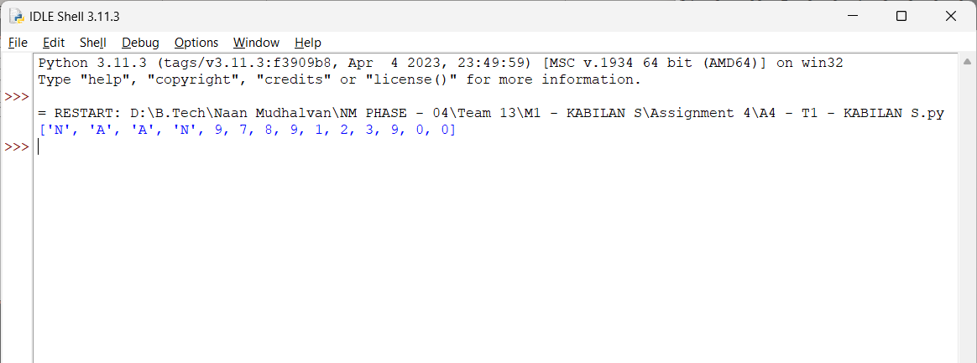

| **Task - 2** | **With if statement find the even numbers.** |
| --- | --- |
| **Coding:** |  |
| list1 = [1, 2, 3, 4]  list2 = [9, 7, 8, 9, 1, 2, 3, 9, 6, 0]  list3=list1.extend(list2) for n in list(n%2==0)  print(n, end=" ") | |
| **Output:** |  |

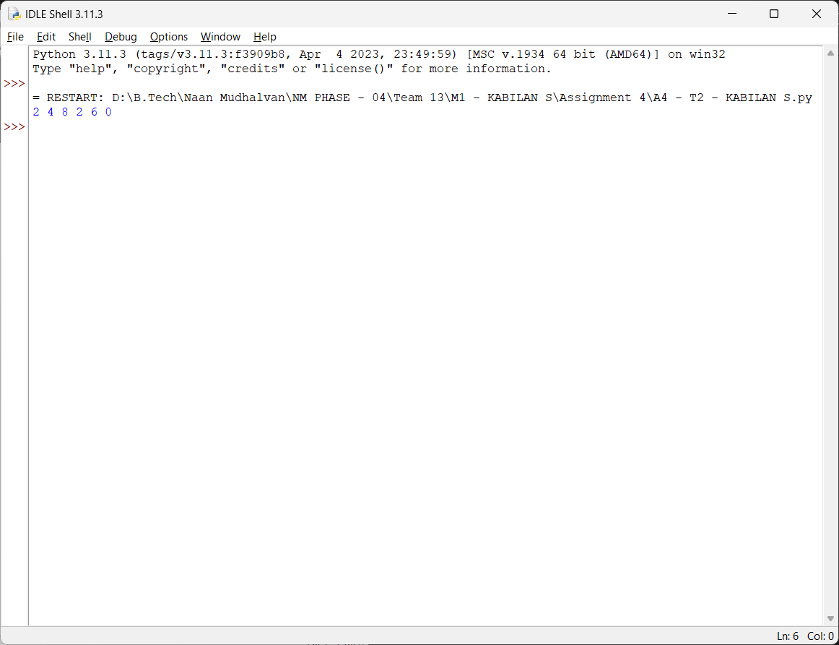

| **Task – 3** | **Create a Dictionary with 3 keys and 2 values for each key.** |
| --- | --- |
| **Coding:** |  |
| k = {'K':[99, 89],'L':[31, 12],'M':[39, 9]}  print(k) | |
| **Output:** |  |

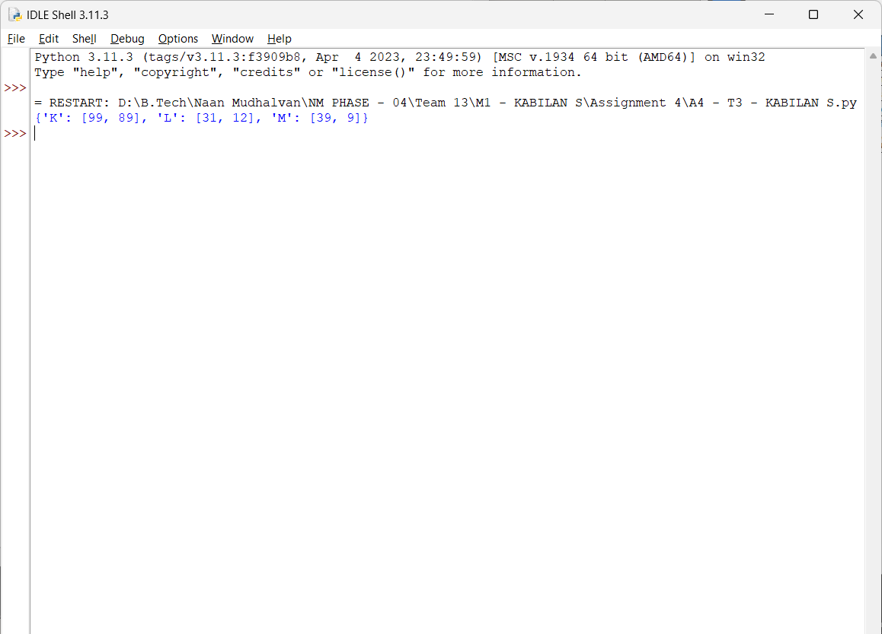

| **Task – 4** | **Create a function with if statement which is used to find the odd numbers.** |
| --- | --- |
| **Coding:** |  |
| def odd_elements(dictionary):  return {key: [x for x in value if x % 2 != 0] for key, value in dictionary.items()} dictionary = {'K':[99, 89],'L':[31, 12],'M':[39, 9]}  filter_dict = odd_elements(dictionary) print(filter_dict) | |
| **Output:** |  |

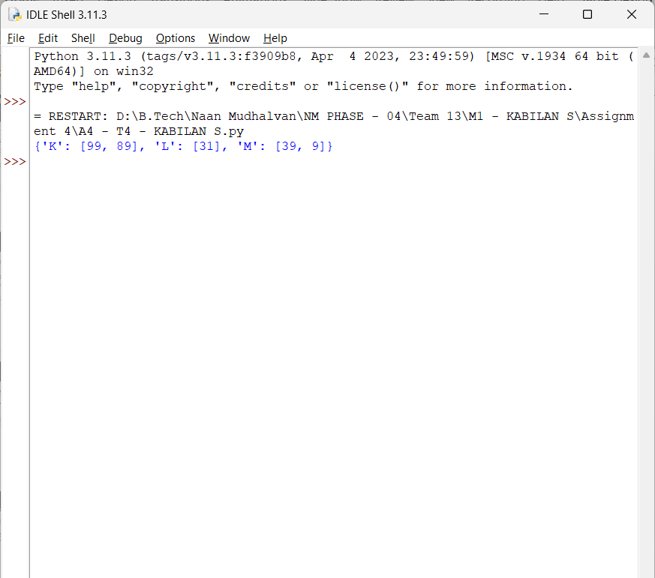

| **Task – 5** | **Write a Python function to sum all the numbers in a list.Sample List : (8,2,3,0,7) Expected Output : 20** |
| --- | --- |
| **Coding:** |  |
| list = [8,2,3,0,7]  print(sum(list)) | |
| **Output:** |  |

